Database Management Systems Lab Work

Practical 4:

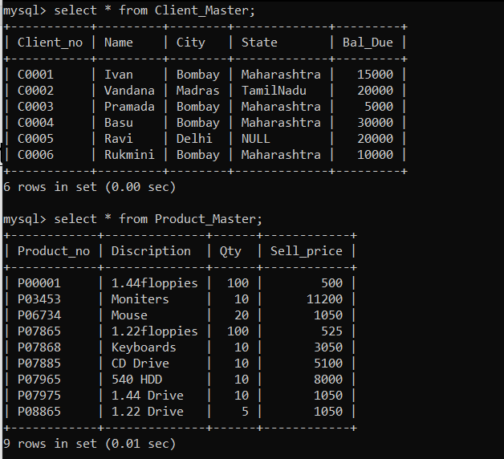

1.Find out the names of all the clients.

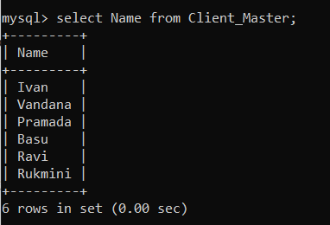

2.Retrieve the list of Name and city of all clients.

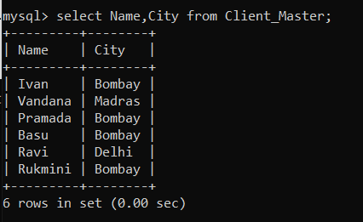

3.List the various products available from the Product_Master table.

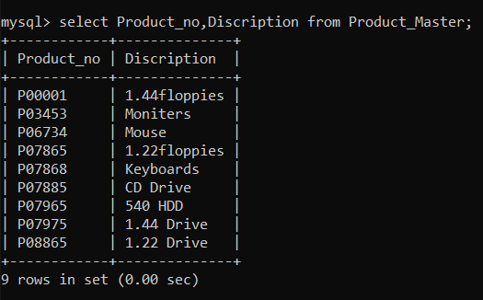

4.List all the clients who are located in Bombay.

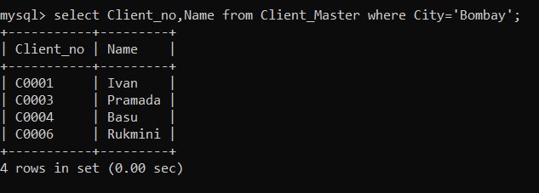

5.Display the information for Client_no C0001 and C0002.

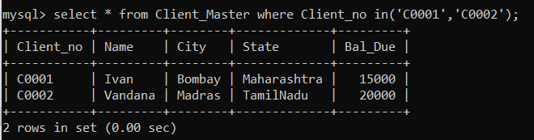

6.Find the products with description as ‘1.44 Drive’ and ‘1.22 Drive’.

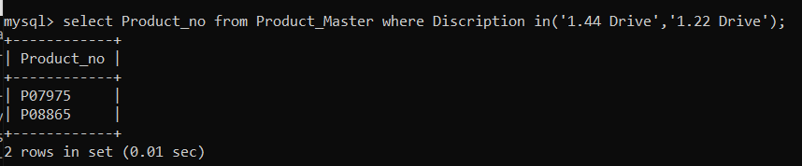

7.Find all the product whose sell price is greater than 5000.

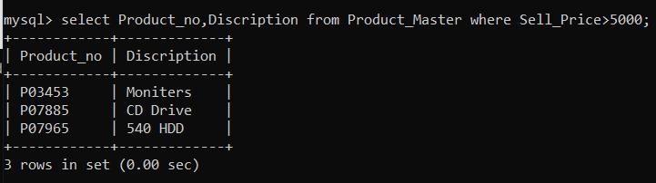

8.Find the product whose selling price is greater than 2000 and is less than equal to 5000.

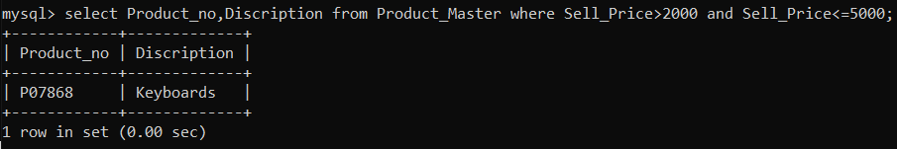

9.List the name, city and state of the client not in the state of ‘Maharashtra’.

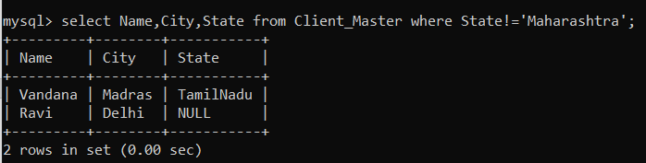

10.Change the city of client C0005 to Bombay.

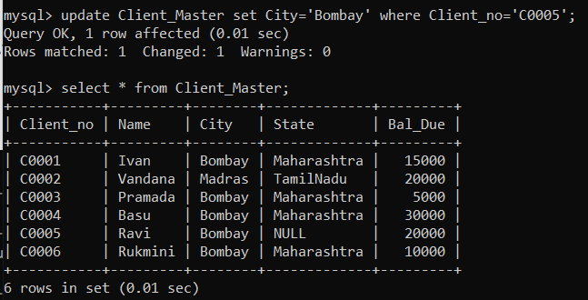

11.Delete all the details of a product where quantity is equal to 100. 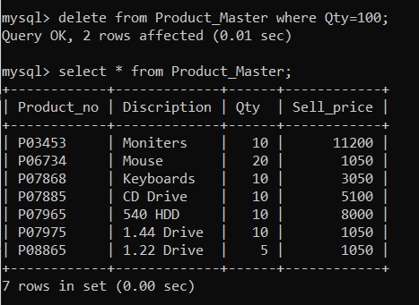

12.Add a column telephone to the table client with domain no(10,0) and add the values for it.

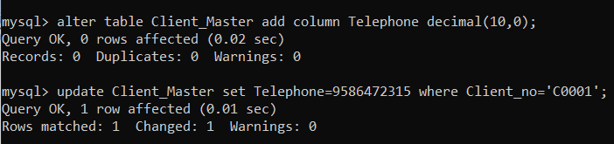

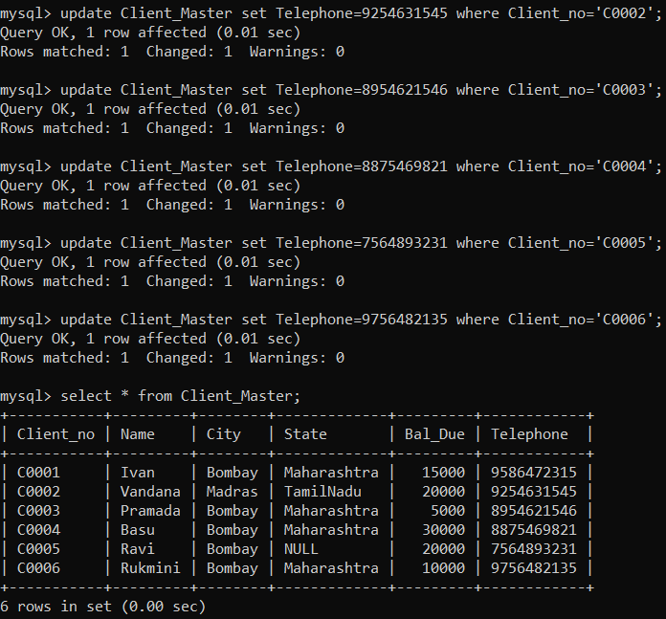

13.Change the size of sell price to 10,2.

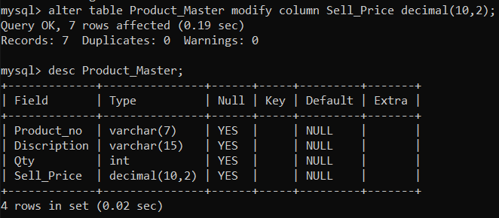

14.Find the names of the clients having ‘a’ as the second letter of the name.

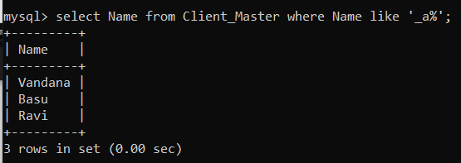

Practical 5:

1.Count the total number of orders placed.

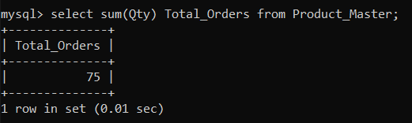

2.Calculate the average price of all the products.

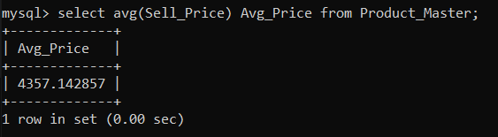

3.Determine the maximum and minimum product prices.

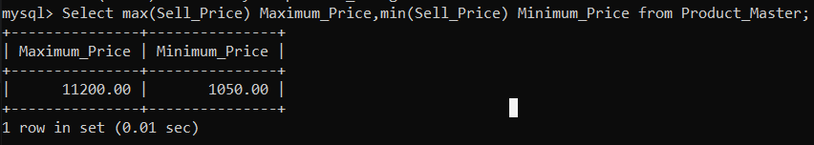

4.Count the number of products having price greater than equal to 1500.

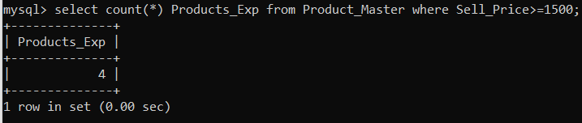

5.Find all the product whose quantity is less than 50.

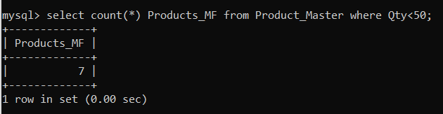

6.Retrieve the city of all clients in lower case letters.

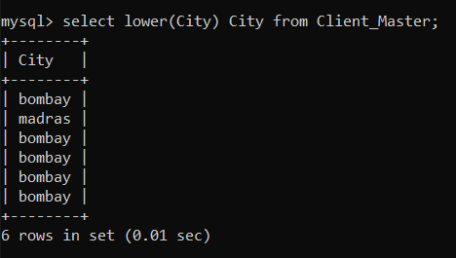

7.Display the state of client no C0002 in upper case.

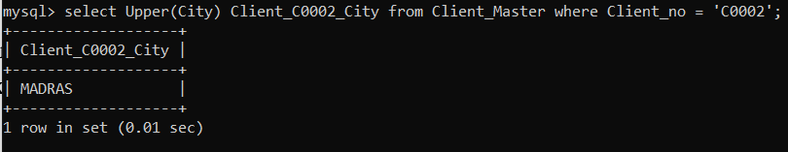

8.Retrieve the city of client by extracting substring from the city column with m=1, n=4.

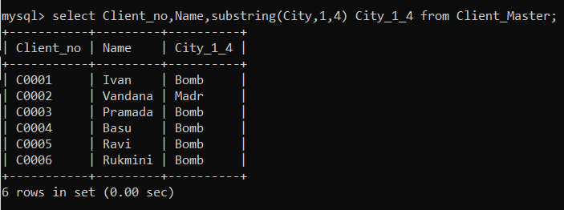

9.Calculate the length of names of clients having Client_no=C0004.

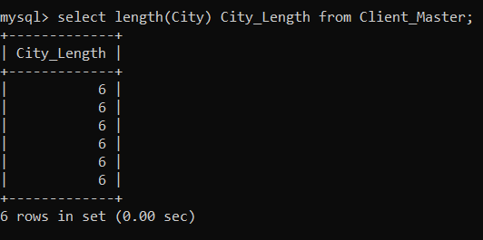

10.Update the table product by adding Rs 1000 to the sell price of all products.

